**Steps to run project**

1. Go to git-hub and clone the project
2. Open the cmd in that respective project folder



1. Now for creating virtual environment, run command **python –m venv myenv** (myenv can be any name)



1. Now go inside myenv folder by using command **cd myenv**



1. Go to the Scripts folder of myenv using **cd Scripts** command



1. To activate the virtual environment run the **activate** command



1. Go back to your project by running two times **cd..** command

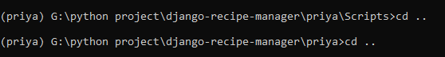

1. Run command **pip install django**



1. After the successfully install run command **pip install pillow**



1. After the successful installation, run the server using the command **python manage.py runserver**



1. After that it give one url with that you can run project in any browser default url is <http://127.0.0.1:8000/>

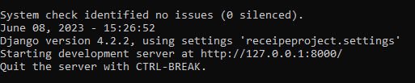

1. After you can see the UI interface of login page where default username and password as following

* username: sam
* Password:123456